10/14/2022
Shane Simpson

2022 Native Aquatic Plant Program
SJRA Lake Conroe Division

Current state of the SJRA nursery:
The Native Aquatic Plant Nursery is located on the San Jacinto River Authority (SJRA) campus at the Lake Conroe Dam and maintained by SJRA staff. The nursery consists of eight troughs that are 4ft wide by 16ft long with a possible water depth of 2ft (fig 1). Four of the troughs are currently devoted to emergent plant species such as water willow, bull rush, spike rush and pickerel weed. The remaining four troughs are dedicated to submergent species, such as Vallisneria, American Lotus, White Water Lily and American Pond Weed. The depth of water is regulated by bulkhead fittings installed on each trough at various depths and a livestock tank water float to ensure appropriate water level. The water float is connected to the nursery’s water supply system which is fed by a well on campus. Shade cloth is used during the hot summer months to mitigate the stress on newly propagated plants and mitigate algae growth. During the fall and early spring, plants are propagated to ensure a harvest for the following year and the most mature plants will be the first ones selected for planting in the summer.

Bulrush American Vallisneria Water Willow
Pond weed Illinois
pond weed

White Water Arrowhead Pickerel
Lily Yellow Water Weed
Lily Spike Rush Water Willow

Fig. 1 Diagram of the runs in the nursery and the current plants that reside.

Monitoring Native Plant Growth and Migration:
There are 41 cages (Table. 1) in the northern part of Lake Conroe that the SJRA, Texas Parks and Wildlife Department (TPWD) and the Lake Conroe Bass Club have constructed to establish native plant species and keep the grass carp from consuming them. The idea is to allow the plants to become well established inside of the cage, then once matured the plant will spread outside of the cage, as well as fragment apart and float to new locations in hope of establishing new colonies of native plant species.
The cages are surveyed multiple times throughout the growing season (spring to fall) to check the integrity of the cages and any new native plant colonies that may have established nearby. First the plants will be checked to see what percentage survived from the previous plantings or what percentage of new growth took place. New plant colonies that have become established outside of the cage will be mapped and monitored for the success of native plant habitation. All mapping and survey data will be collected via the Field Maps application, created by ESRI.
Propagation and plant restocking:
For the second year, SJRA has decided to purchase plants from a grower to help restock the nursery. A third-party vendor was able to grow and supply the SJRA with the following:
- 100 – Pickerel Weed
- 100 – Spike rush
- 50 – Vallisneria
- 100 – American Floating Pondweed
- 150 – Yellow Water Lily
Propagation is also done throughout the growing season by SJRA staff at the onsite nursery. Propagation does supply about 50% to 75% of the plants each season, however, outside supplementation is necessary to meet the stocking goals for the year.
2022 Early season survey:
The SJRA Lake Conroe Operations team conducted a native plant survey for most of the northern portion of Lake Conroe in June of 2022. The survey was done via airboat and began out of the US Forest Service boat ramp at Scotts Ridge as well as the Cagle Campgrounds. The team was able to survey and collect data at all 41 cages as well as new potential planting locations for future efforts (Table 1). We observed an abundance of vegetation, both inside and outside of the cages. Large patches of Vallisneria, American Floating Pondweed were found in shallow water, which has not been seen in many years. The cages harboring plants were exceeding the limits of the cage and starting to grow in large patches immediately outside of the enclosure. A hand full of cages were opened or damaged and I will schedule a cleanup day in the future to either fix or remove some of these cages. I would also like to add PVC poles with reflective tape at each cage location to detour boats from running over and damaging a boat and the cage. It was observed that a handful of cages had patches of hydrilla growing in and around them and have been treated with ProcellaCor. Water willow is well established throughout the area and was found in large stands along the entire shoreline, as well as Bull Rush, Spike Rush and Picklerweed that also were flourishing in abundance in the upper reaches of Caney Creek.

2022 First planting:
During the 2022 planting season we decided to focus our efforts in new areas outside of Caney Creek, where areas were void of vegetation, or lacked diversity (Fig. 2,3, and 5). Caney Creek is abundant with native species along throughout the entire reaches and further efforts to plant did not seem beneficial with the limited resources at hand.
In late June, employees from the Lake Conroe division and two employees from Stonefly Aquatic Nurseries conducted the first round of native planting in new locations that have not been targeted in previous planting efforts. These new locations were selected based on the following factors: protection from wind and wave action, water depth, amount of exposed shoreline, and access. The planting effort locations, plant species and number of each plant species introduced are visible in (Fig. 2, 3, 4 and 5).
In Most of the planting locations we encountered either a sandy or clay substrate. The sandy substrate can create obstacles in planting efforts since it may not sufficiently hold the roots in place when new plants are introduced causing a small number of plants to float up if not planted at the correct depth. Our hope is that the ones that do float away are not a total loss and will establish in new locations.
The staff at Stonefly Aquatics brought valuable expertise and suggested various planting techniques to the SJRA, including plant placement, plant grouping and depth considerations. Because of this close working relationship we were able to implement our current planting techniques with the advice of Stonefly aquatics to achieve a more successful planting effort.
2022 Second Planting:
The second planting effort of the season was conducted in mid-August and was focused on a cove two and half miles north of Caney Creek on the Northwest side of Lake Conroe (Fig. 4). This cove has been targeted in previous planting efforts; however, the project area was sporadic and did not produce the desired result. During this planting effort we decided to take a different approach and introduced “clusters” of plants in close proximity to each other. The submergent species were planted in about two feet of water giving the lilies enough height to break the water surface with one or more leaves. Vallisneria and Pondweed were introduced in a water depth of two feet or less and in groups of 15 to 20 plants. The emergent species were planted along the shoreline in one foot of water or less in rows along the shoreline and staggard every one foot and in groups of 10 to 15 plants. Throughout the entirety of the planting season were cognizant of the lake level variations as to not leave the plants without water. The quantities by species and their locations are shown in Fig. 4.

Cage# | Species | Second Species | % Full
1 | Empty |  | 0
2 | Pondweed |  | 25
3 | Empty |  | 0
4 | American Pondweed |  | 50
5 | Empty |  | 0
6 | Empty |  | 0
7 | Empty |  | 0
8 | Empty |  | 0
9 | Hydrilla |  | 50
10 | Hydrilla | Pondweed | 100
11 | Empty |  | 0
12 | Empty |  | 0
13 | Empty |  | 0
14 | Empty |  | 0
15 | Pondweed | Lily | 100
16 | Empty |  | 0
17 | Empty |  | 0
18 | Empty |  | 0
19 | Empty |  | 0
20 | Empty |  | 0
21 | Empty |  | 0
22 | Hydrilla |  | 50
23 | Empty |  | 0
24 | Pondweed | Vallisneria | 100
25 | Empty |  | 0
26 | Empty |  | 0
27 | Vallisneria |  | 100
28 | Empty |  | 0
29 | Empty |  | 0
30 | Empty |  | 0
31 | Vallisneria |  | 50
32 | Vallisneria |  | 50
33 | Hydrilla |  | 100
34 | Empty |  | 0
35 | Empty |  | 0
36 | Empty |  | 0
37 | Pondweed |  | 100
38 | Empty |  | 0
39 | Empty |  | 0
40 | Empty |  | 0
41 | Pondweed |  | 100

Table 1: Species per cage and percent full

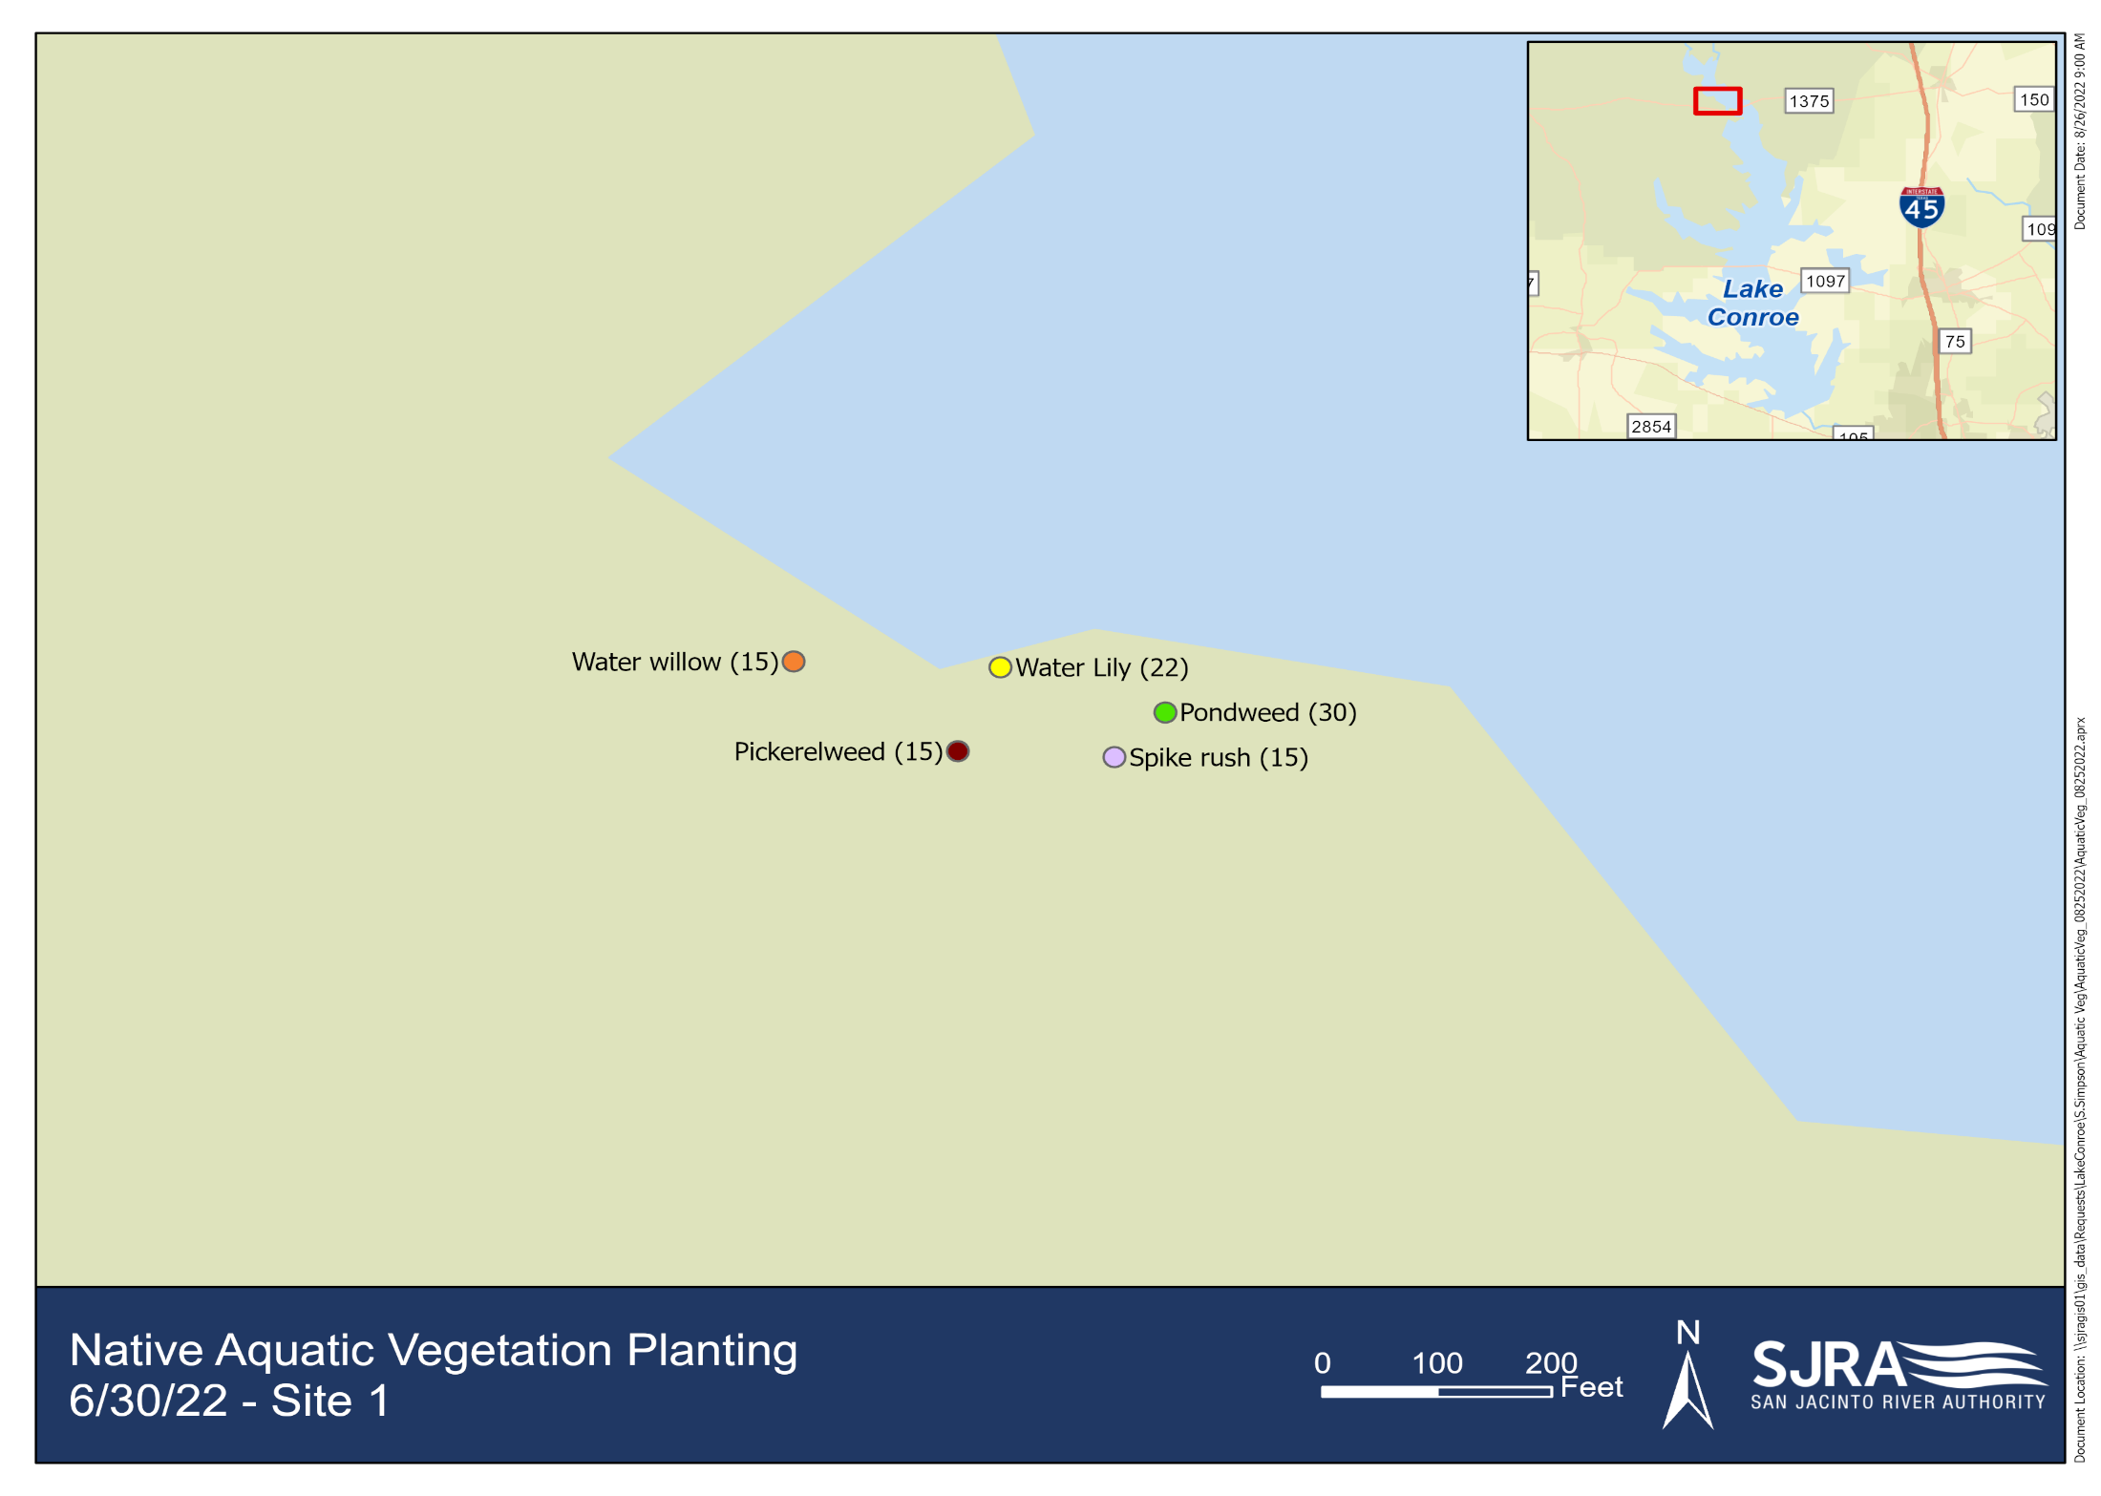
Fig 2: Native Aquatic Vegetation Planting
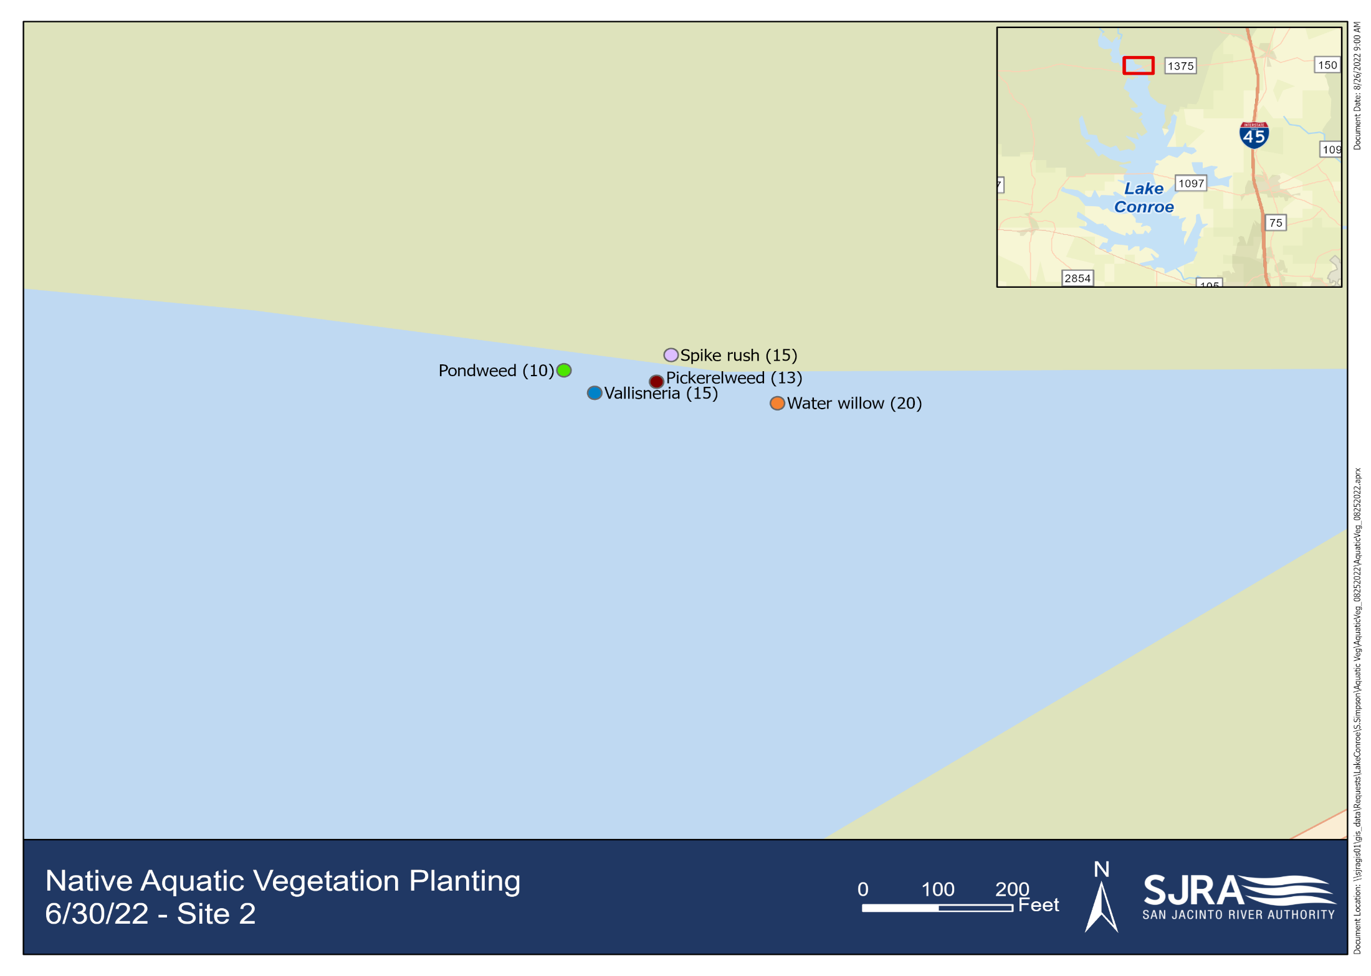
Fig 3: Native Aquatic Vegetation Planting
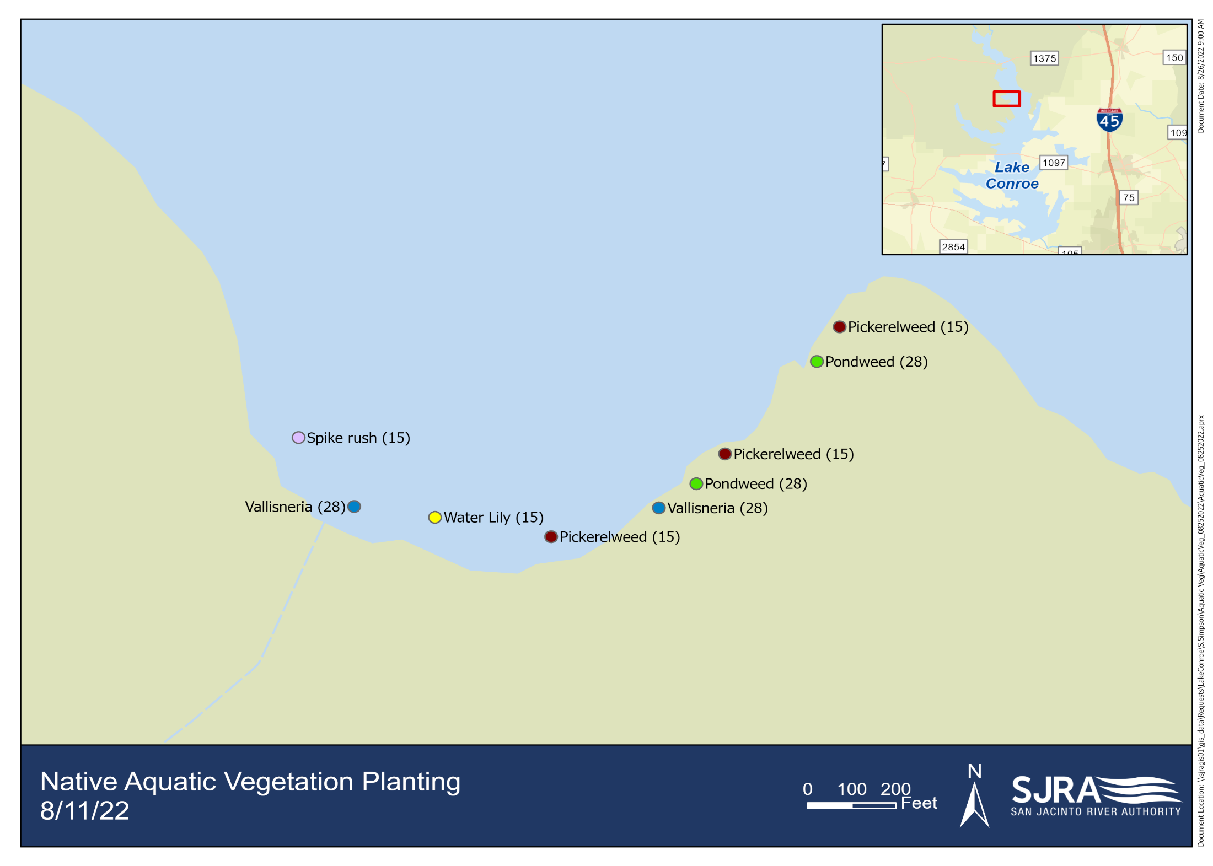
Fig 4: Native Aquatic Vegetation Planting
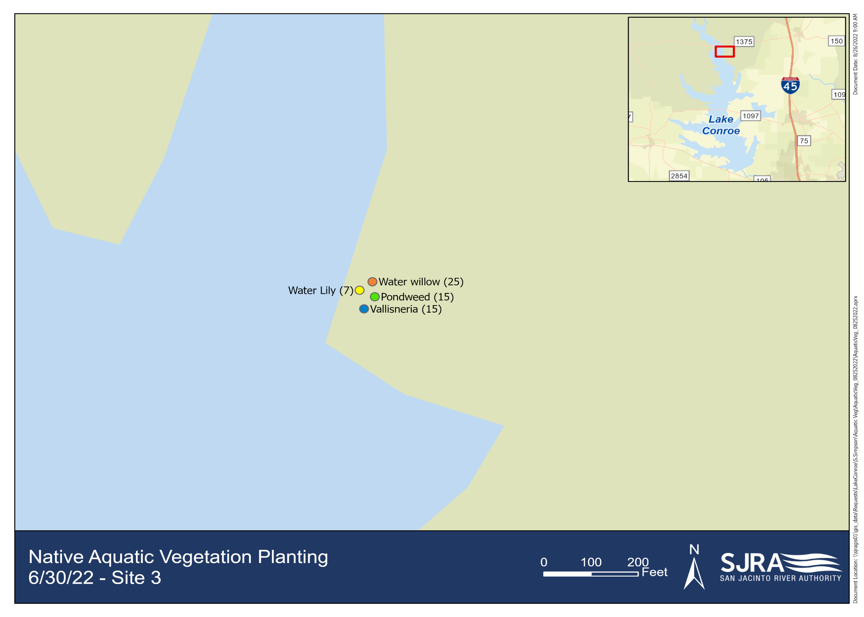
Fig 5: Second Native Aquatic Planting

