2/7/2023
Shane Simpson
SJRA Lake Conroe Division

Lake Conroe Clean Rivers Program Fourth Quarter 2022
Clean Rivers Sampling Program
The San Jacinto River Authority participates in and contributes to the Clean Rivers Program (CRP) by sampling Lake Conroe and its tributaries at various sites on a monthly basis (Fig 1). The collected water quality samples are transported and delivered to the City of Houston Water Quality Laboratory for analysis. The Clean Rivers Program is managed regionally by the Houston Galveston Area Council (H-GAC). The H-GAC disseminates the laboratory results through its website www.h-gac.com. Annually the “Basin Highlights/ Summary Report” is created to give an update on the health of the local waterways. The health of the waterway is rated by a frog chart and the more frogs that are given the healthier the water (Fig 2). You can find the “Basin Highlights/ Summary Report here: https://www.h-gac.com/clean-rivers-program/basin-highlights-summary-reports.aspx
There are 10 water quality monitoring stations in the Lake Conroe watershed (Fig. 1). The CRP sites are all located in the main body of the lake or at the mouth of major tributaries and were chosen to capture water quality from all tributaries to represent the mixing of all inflow. At each site there are “grab samples” and instantaneous monitoring done. The grab samples are collected in bottles to be sent to the lab for analysis. Instantaneous monitoring is done with a water quality sonde that gives very useful real time data from different depths in the water column. The data gathered from each sampling event is compared to the TCEQ water quality standards and screening levels (Table 1). The standards and screening levels are set for each water body by TCEQ based on the “use”. Lake Conroe’s uses are drinking water, fish consumption and recreation.
2022 Fourth Quarter Review
Fourth quarter sampling went smoothly besides the month of December. We were not able to make the sampling work with staff being out, lab scheduling and weather.
We had one exceedence in August at site 6 for phosphorus and one exceedance in October at site 10 for Ammonia Nitrogen. These both barely exceeded the TCEQ screening levels for Lake Conroe.
TKN and Chlorophyll-a were sampled for at four locations in September. Three out of the four locactions exceeded the screening levels set by TCEQ for Lake Conroe.
All data was below TCEQ standards and screening levels for the fourth quarter of 2022.
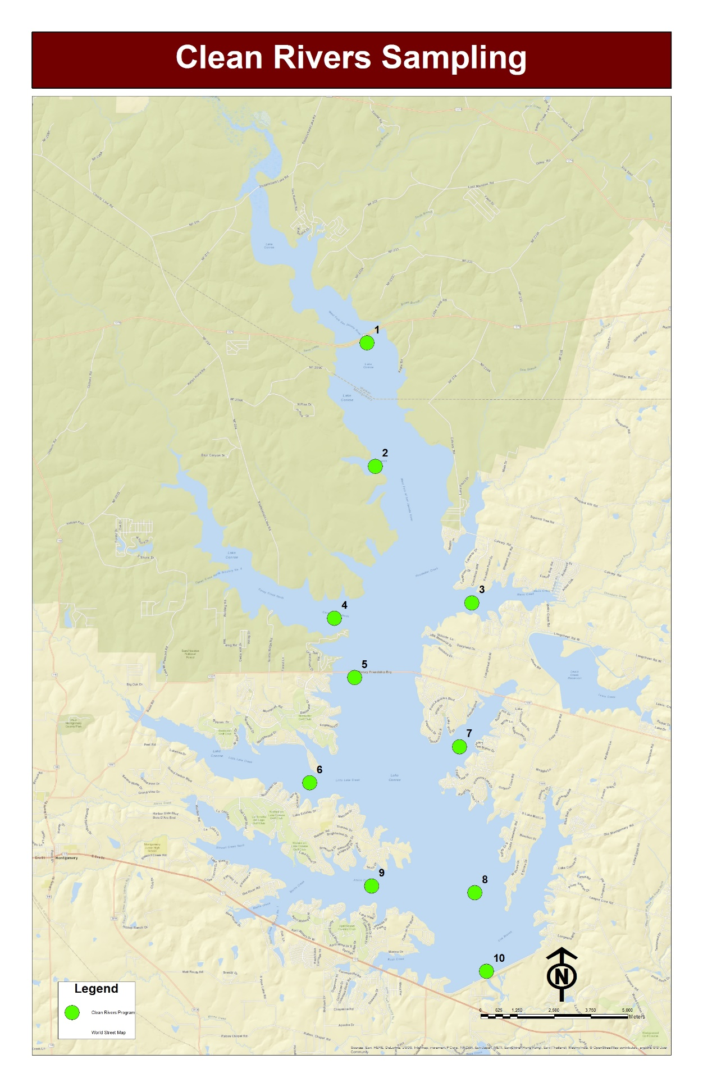

Fig 1: CRP Lake Conroe sampling locations

Table 1. Water Quality Standards and Screening Levels

Parameter | Criterion Type | Standard or Screening Level
Total Phosphorus | 2014 TCEQ Screening Level | 0.20 mg/L
Total Dissolved Solids | 2014 Water Quality Standard | 300 mg/L
Temperature | 2014 Water Quality Standard | 32.22C
Sulfate | 2014 Water Quality Standard | 50 mg/L
Orthophosphate-P | 2014 TCEQ Screening Level | 0.05 mg/L
Nitrate-N | 2014 TCEQ Screening Level | 0.37 mg/L
Enterococci | Special Project | 35 MPN/100 mL
E. Coli | 2014 Water Quality Standard | 126 MPN/100 mL
Dissolved Oxygen (single sample minimum) | 2014 Water Quality Standard | 3.0 mg/L
Dissolved Oxygen (minimum 24-hour mean) | 2014 Water Quality Standard | 5.0 mg/L
Chlorophyll a | 2014 TCEQ Screening Level | 26.7 Micrograms / L
Chloride | 2014 Water Quality Standard | 50 mg/L
Ammonia-N | 2014 TCEQ Screening Level | 0.11 mg/L
Table 1: TCEQ Screening Levels and Standards for the water quality parameters

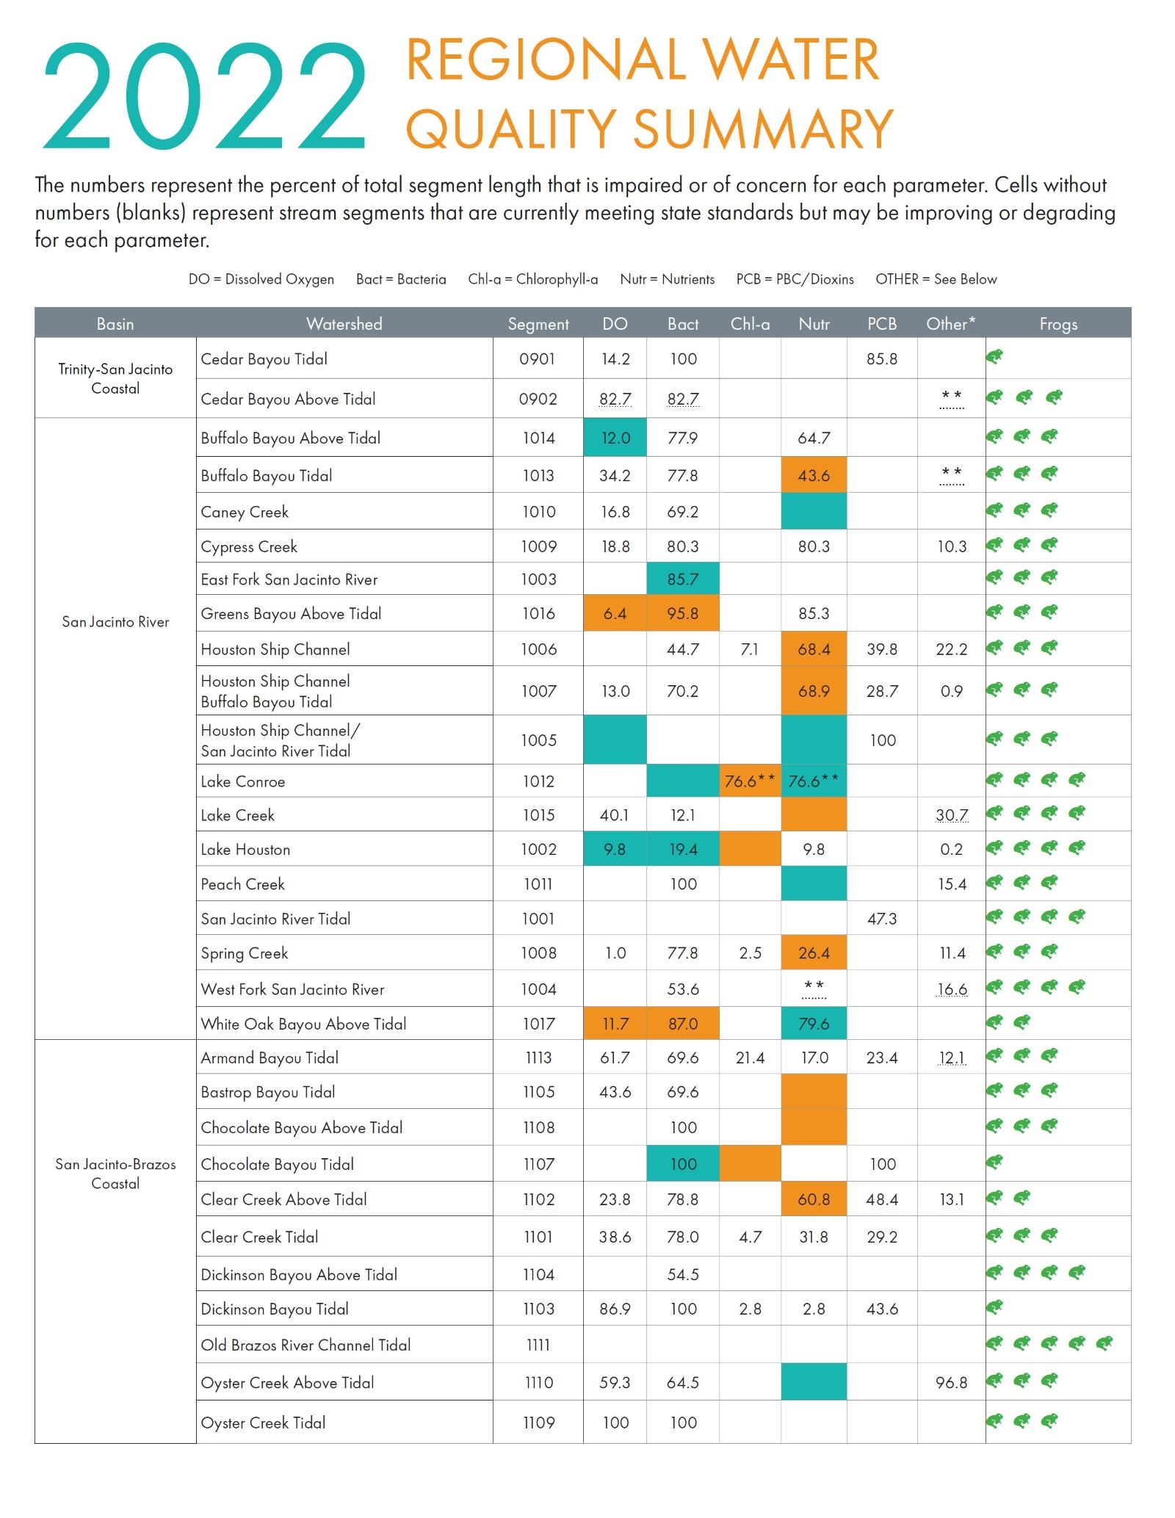
Fig 2: Regional Water Quality Summary (Frog Chart)

The following tables 2-4 show the water quality data for August - November. Any data that exceeds the TCEQ screening levels or set standards, is indicated by a red font. Any data with a “<” indicates that the measurement for this parameter was below detection levels. New to this report is a row with the TCEQ standards and screenings levels to aid in reviewing the data.

Lake Conroe – August 2022
Lab |  |  |  |  |  |  |  |  |  |  |  |  |  | Field
TCEQ standards/ screening levels |  | N/A | >50 | >126 | 0.11 | >.37 | N/A | >50 | >.20 | N/A | >26.7 | N/A | <3.0 |  | N/A | >32.22 | N/A
Date | Site | Alk mg/L | Chlor-ide mg/L | E Coli MPN/ 100mL | NH3_N mg/L | NO2_N mg/L | NO3_N  Mg/L | Sulfate mg/L | T-PO4_P mg/L | TSS  Mg/L | Chlor-ophyll | TKN | DO |  | Spec/ Cond | Temp  *C | pH
8/3/2022 | 1 | 71 | 27 | 11.0 | < 0.1 | < 0.04 | < 0.04 | 5 | 0.16 | 25 | N/A | N/A | 5.79 |  | 191.6 | 30.79 | 8.73
8/3/2022 | 2 | 69 | 27 | < 1.0 | < 0.1 | < 0.04 | < 0.04 | 5 | 0.11 | 15 | N/A | N/A | 6.78 |  | 185.2 | 31.46 | 8.94
8/3/2022 | 3 | 72 | 26 | 5.1 | < 0.1 | < 0.04 | < 0.04 | 5 | 0.12 | 16 | N/A | N/A | 8.59 |  | 185.2 | 31.65 | 9.11
8/3/2022 | 4 | 70 | 26 | < 1.0 | < 0.1 | < 0.04 | < 0.04 | 6 | 0.15 | 11 | N/A | N/A | 7.52 |  | 186.8 | 30.83 | 8.85
8/3/2022 | 5 | 72 | 26 | 1.0 | < 0.1 | < 0.04 | < 0.04 | 6 | 0.06 | 11 | N/A | N/A | 7.09 |  | 188 | 30.5 | 8.87
8/3/2022 | 6 | 73 | 26 | < 1.0 | < 0.1 | < 0.04 | < 0.04 | 6 | 0.25 | 9 | N/A | N/A | 6.88 |  | 188.9 | 30.53 | 8.87
8/3/2022 | 7 | 70 | 26 | < 1.0 | < 0.1 | < 0.04 | < 0.04 | 6 | 0.05 | 11 | N/A | N/A | 8.67 |  | 186.2 | 31.11 | 9.02
8/3/2022 | 8 | 72 | 25 | 2.0 | < 0.1 | < 0.04 | < 0.04 | 5 | 0.06 | 8 | N/A | N/A | 6.54 |  | 189.8 | 30.24 | 8.52
8/3/2022 | 9 | 70 | 25 | 2.0 | < 0.1 | < 0.04 | < 0.04 | 7 | 0.10 | 7 | N/A | N/A | 6.07 |  | 190.9 | 29.94 | 8.45
8/3/2022 | 10 | 74 | 25 | < 1.0 | < 0.1 | < 0.04 | < 0.04 | 6 | 0.08 | 8 | N/A | N/A | 7.2 |  | 191.4 | 30.02 | 8.59
Table 2: CRP Lake Conroe August 2022 data for all 10 sites
Table 3: Lake Conroe CRP data for July 2018
Lake Conroe – September 2022
Lab |  |  |  |  |  |  |  |  |  |  |  |  |  | Field
TCEQ standards/ screening levels |  | N/A | >50 | >126 | 0.11 | >.37 | N/A | >50 | >.20 | N/A | >26.7 | N/A | <3.0 |  | N/A | >32.22 | N/A
Date | Site | Alk mg/L | Chlor-ide mg/L | E Coli MPN/ 100mL | NH3_N mg/L | NO2_N mg/L | NO3_N  mg/L | Sulfate mg/L | T-PO4_P mg/L | TSS  Mg/L | Chlor-ophyll | TKN | DO |  | Spec/ Cond | Temp  *C | pH
9/7/2022 | 1 | 73 | 29 | 1.0 | < 0.1 | < 0.04 | < 0.04 | 6 | 0.13 | 16 | 43.5 | 1.6 | 10.59 |  | 239.4 | 30.27 | 9.27
9/7/2022 | 2 | 72 | 27 | < 1.0 | < 0.1 | < 0.04 | < 0.04 | < 5 | 0.11 | 14 | N/A | N/A | 10.46 |  | 235.5 | 30.59 | 9.14
9/7/2022 | 3 | 72 | 26 | 1.0 | < 0.1 | < 0.04 | < 0.04 | < 5 | 0.10 | 11 | N/A | N/A | 13.49 |  | 234 | 30.54 | 9.39
9/7/2022 | 4 | 71 | 26 | < 1.0 | < 0.1 | < 0.04 | < 0.04 | < 5 | 0.09 | 9 | N/A | N/A | 8.08 |  | 237.5 | 29.61 | 8.82
9/7/2022 | 5 | 72 | 27 | 5.2 | < 0.1 | < 0.04 | < 0.04 | 7 | 0.09 | 8 | 59.8 | 1.3 | 8.75 |  | 237.5 | 29.71 | 8.86
9/7/2022 | 6 | 73 | 26 | < 1.0 | < 0.1 | < 0.04 | < 0.04 | < 5 | 0.11 | 8 | N/A | N/A | 7.01 |  | 240.2 | 29.37 | 8.61
9/7/2022 | 7 | 73 | 30 | 2.0 | < 0.1 | < 0.04 | < 0.04 | 8 | 0.08 | 9 | N/A | N/A | 11.49 |  | 239.6 | 30.48 | 9.21
9/7/2022 | 8 | 73 | 26 | < 1.0 | < 0.1 | < 0.04 | < 0.04 | < 5 | 0.08 | 8 | 47.3 | 1.2 | 12.28 |  | 237.7 | 30.8 | 9.25
9/7/2022 | 9 | 74 | 26 | 2.0 | < 0.1 | < 0.04 | 0.05 | 5 | 0.09 | 7 | N/A | N/A | 6.26 |  | 244.4 | 29.29 | 8.42
9/7/2022 | 10 | 73 | 26 | 2.0 | < 0.1 | < 0.04 | 0.15 | < 5 | 0.09 | 5 | 25 | 1.0 | 2.17 |  | 243.3 | 28.82 | 7.67
Table 3: CRP Lake Conroe September 2022 data for all 10 sites

Lake Conroe – October 2022
Lab |  |  |  |  |  |  |  |  |  |  |  |  |  | Field
TCEQ standards/ screening levels |  | N/A | >50 | >126 | 0.11 | >.37 | N/A | >50 | >.20 | N/A | >26.7 | N/A | <3.0 |  | N/A | >32.22 | N/A
Date | Site | Alk mg/L | Chlor-ide mg/L | E Coli MPN/ 100mL | NH3_N mg/L | NO2_N mg/L | NO3_N  mg/L | Sulfate mg/L | T-PO4_P mg/L | TSS  Mg/L | Chlor-ophyll | TKN | DO |  | Spec/ Cond | Temp  *C | pH
10/5/2022 | 1 | 74 | 29 | < 1.0 | < 0.1 | < 0.04 | < 0.04 | < 5 | 0.18 | 15 | N/A | N/A | 10.14 |  | 246.9 | 25.05 | 9.23
10/5/2022 | 2 | 74 | 28 | 2.0 | < 0.1 | < 0.04 | < 0.04 | < 5 | 0.07 | 15 | N/A | N/A | 8.78 |  | 242.6 | 25.45 | 8.95
10/5/2022 | 3 | 76 | 27 | < 1.0 | < 0.1 | < 0.04 | < 0.04 | < 5 | 0.06 | 11 | N/A | N/A | 10.76 |  | 242.2 | 26.24 | 9.06
10/5/2022 | 4 | 77 | 28 | 2.0 | < 0.1 | < 0.04 | < 0.04 | < 5 | 0.06 | 9 | N/A | N/A | 7.17 |  | 244.4 | 26.2 | 8.48
10/5/2022 | 5 | 74 | 28 | < 1.0 | < 0.1 | 0.04 | < 0.04 | < 5 | 0.05 | 8 | N/A | N/A | 4.86 |  | 245.6 | 26.05 | 7.97
10/5/2022 | 6 | 76 | 29 | < 1.0 | < 0.1 | < 0.04 | < 0.04 | < 5 | 0.05 | 9 | N/A | N/A | 7.58 |  | 245.9 | 26.08 | 8.63
10/5/2022 | 7 | 76 | 29 | < 10.0 | < 0.1 | < 0.04 | < 0.04 | < 5 | 0.06 | 9 | N/A | N/A | 9.69 |  | 244.1 | 226.5 | 8.77
10/5/2022 | 8 | 78 | 29 | 1.0 | < 0.1 | < 0.04 | 0.05 | < 5 | 0.05 | 8 | N/A | N/A | 8.44 |  | 246.1 | 26.85 | 8.64
10/5/2022 | 9 | 78 | 29 | < 1.0 | < 0.1 | < 0.04 | < 0.04 | < 5 | 0.04 | 9 | N/A | N/A | 6.11 |  | 249.2 | 26.06 | 8.21
10/5/2022 | 10 | 79 | 29 | < 1.0 | 0.15 | 0.05 | 0.05 | < 5 | 0.05 | 9 | N/A | N/A | 2.03 |  | 250.3 | 26.04 | 7.57
Table 4: CRP Lake Conroe October 2022 data for all 10 sites

Lake Conroe – November 2022
Lab |  |  |  |  |  |  |  |  |  |  |  |  |  | Field
TCEQ standards/ screening levels |  | N/A | >50 | >126 | 0.11 | >.37 | N/A | >50 | >.20 | N/A | >26.7 | N/A | <3.0 |  | N/A | >32.22 | N/A
Date | Site | Alk mg/L | Chlor-ide mg/L | E Coli MPN/ 100mL | NH3_N mg/L | NO2_N mg/L | NO3_N  mg/L | Sulfate mg/L | T-PO4_P mg/L | TSS  Mg/L | Chlor-ophyll | TKN | DO |  | Spec/ Cond | Temp  *C | pH
11/29/2022 | 1 | 74 | 29 | 10.0 | < 0.1 | < 0.04 | 0.07 | 8 | 0.04 | 12 | N/A | N/A | 10.84 |  | 248.6 | 16.88 | 8.46
11/29/2022 | 2 | 75 | 26 | < 10.0 | < 0.1 | < 0.04 | 0.12 | 7 | 0.04 | 7 | N/A | N/A | 9.71 |  | 239.2 | 16.05 | 8.15
11/29/2022 | 3 | 76 | 26 | < 10.0 | < 0.1 | < 0.04 | 0.14 | 6 | 0.03 | 10 | N/A | N/A | 11.2 |  | 236.2 | 17.2 | 8.53
11/29/2022 | 4 | 74 | 26 | < 10.0 | < 0.1 | < 0.04 | 0.19 | 6 | 0.04 | 5 | N/A | N/A | 9.35 |  | 236.6 | 16.32 | 7.98
11/29/2022 | 5 | 75 | 26 | < 10.0 | < 0.1 | < 0.04 | 0.22 | 6 | 0.04 | 6 | N/A | N/A | 9.52 |  | 236.5 | 15.91 | 7.97
11/29/2022 | 6 | 75 | 26 | 10.0 | < 0.1 | < 0.04 | 0.26 | 6 | 0.03 | 5 | N/A | N/A | 8.15 |  | 238.3 | 15.95 | 7.66
11/29/2022 | 7 | 75 | 26 | 20.0 | < 0.1 | < 0.04 | 0.27 | 6 | 0.05 | 6 | N/A | N/A | 9.32 |  | 238.8 | 16.34 | 7.93
11/29/2022 | 8 | 74 | 27 | < 10.0 | < 0.1 | < 0.04 | 0.29 | 7 | 0.06 | 5 | N/A | N/A | 9.28 |  | 238.3 | 16.09 | 7.88
11/29/2022 | 9 | 76 | 27 | < 10.0 | < 0.1 | < 0.04 | 0.29 | 7 | 0.06 | 6 | N/A | N/A | 8.6 |  | 239.4 | 16.09 | 7.73
11/29/2022 | 10 | 74 | 26 | < 10.0 | < 0.1 | < 0.04 | 0.34 | 7 | 0.04 | 4 | N/A | N/A | 6.91 |  | 240.7 | 15.81 | 7.49
Table 5: CRP Lake Conroe November 2022 data for all 10 sites

Appendix:
Total Phosphorus:
Phosphorus is a nutrient important for plant growth. In most lakes, phosphorus is the limiting nutrient, which means that everything that plants and algae need to grow is available in excess, (sunlight, warmth, water nitrogen, etc.) except phosphorus. Phosphorus has a direct effect on algae growth, so the more phosphorus the more algae. Phosphorus can come from nature and man-made sources, such as soil erosion, waste water plants, septic systems, runoff and fertilizer.
Total Phosphorus (TP) is a measurement of Ortho-phosphate and phosphorus. Orthophosphates is the chemically active dissolved form of phosphorus that is taken up directly by plants. Orthophosphates come from the breakdown of rocks and minerals, as well as man-made sources like waste water plants, agriculture runoff and fertilizers. Phosphorus is found in the animal tissue and plant fragments suspended in the water.
Another way phosphorus inters the water column is from the bottom and up and this is called internal loading. When the bottom of the lake is anoxic during the hottest parts of the summer, the sediment water interface has a chemical reaction causing the water to become phosphorus rich. Once the lake starts mixing again, through the stratified levels, it brings phosphorus to the top of the water column were more plants and algae can take it up.
Total Dissolved Solids:
Total Dissolved Solids (TDS) is the measurement of the dissolved combined content of inorganic and organic substances present in a liquid in molecular, ionized, or micro-granular suspended form. TDS is measured in freshwater for the amount of ions in the water, which is usually referred to as salinity. The Texas Commission on Environmental Quality has set a standard for all freshwater systems of 300mg/L of TDS. High TDS levels can give an indication of chemical contaminants in the water, such as agricultural runoff, sewage, fertilizers and sediment runoff from construction sites. High TDS levels can also effect the different aquatic species in the freshwater environment. Each species has a certain threshold that they can survive in and reproduce. If the TDS levels are too high it greatly effect to the small offspring and reproductions levels.
Temperature:
Water temperature is an important factor in an aquatic ecosystem because it controls biological activities and chemical processes. Many species depend on the environment to regulate metabolic rates and have certain temperature ranges they can handle. Temperature also affects the amount of dissolved oxygen that is available to aquatic organisms. As a general rule, cool water is capable of retaining more dissolved oxygen than warm water. Generally as the water temperature increases, metabolic activities increase such as respiration, but the amount of oxygen in the water decreases. Wastewater plants, stormwater and loss of natural steam cover are all things that can affect the temperature of a stream or reservoir.
Sulfate:
Sulfates can be naturally occurring or the result of municipal or industrial discharges. When naturally occurring, they are often the result of the breakdown of leaves that fall into a stream, water passing through rock or soil containing gypsum and other common minerals, or atmospheric deposition like acid rain. Point sources include sewage treatment plants and industrial discharges such as tanneries, pulp mill, fertilizers and agricultural runoff. Sulfates can be an indicator of possible pollution runoff into the reservoir and can also have great effect on pH at high concentrations.
Orthophosphate-P:
Orthophosphate is the chemically active dissolved form of phosphorus that can be directly taken up by plants. Orthophosphates can also come from the breakdown of rocks and minerals, as well as man-made sources like waste water plants, agriculture runoff and fertilizers. Orthophosphates can cause rapid algae growth in surface waters, which can deplete sunlight and oxygen levels and harm fish populations.
Nitrate- N:
Nitrates in the water are from fertilizer runoff, leaky OSSF’s, sewage treatment plants, agriculture runoff, pet waste and wild animal feces. Nitrates are an essential part of plant growth and have the same effect on plats as phosphorus. The plants and algae are stimulated, which is good in small amounts but with too much growth there is a decline in the water quality due to lower oxygen levels and light penetration to lower growing vegetation.
E Coli:
This bacteria is a preferred indicator for fecal contamination from warm blooded animals. Although usually harmless, E. coli can cause illnesses such as meningitis, septicemia, and urinary tract infections. This indicator species is mainly samples for to see if the waterbody is suitable for recreational use.
Dissolved Oxygen:
Dissolved oxygen (DO) is the amount of oxygen that is present in water. Water bodies receive oxygen form the atmosphere and from aquatic plants. Running water, such as that of a swift moving stream, dissolves more oxygen than the still water of a pond or lake. All aquatic animals need DO to breathe. Low levels of oxygen (hypoxia) or no oxygen levels (anoxia) can occur when excess organic materials, such as large algal blooms, are decomposed by microorganisms. During this decomposition process, DO in the water is consumed. Lower DO levels are usually toward the bottom of the water column and this can change with the seasons and water temperature. Low DO levels can kill some fish and other aquatic organisms.
Chlorophyll-a:
Chlorophyll allows plants (including algae) to photosynthesize, i.e., use sunlight to convert simple molecules into organic compounds. Chlorophyll a is the predominant type of chlorophyll found in green plants and algae. Chlorophyll a is a measure of the amount of algae growing in a waterbody. Some algae is an ok for a freshwater ecosystem, but too much algae can cause aesthetic problems and decreased dissolved oxygen levels. Some algae can produce toxins that can cause a public health concern when found in high concentrations.
Chloride:
Chloride in in water is a dissolved solid and makes up the ions found in freshwater lakes and streams. Chloride can end up in freshwater from salting of roads, over fertilization and wastewater. Chloride is directly correlated to the salinity in the water. Too much salinity in freshwater can harm the aquatic ecosystem because most species have a range of saintly levels they can live in.
Ammonia-N:
Ammonia is one of several forms of nitrogen that exist in aquatic environments. Unlike other forms of Nitrogen Ammonia can cause direct toxic effects on aquatic life. Ammonia can enter into waterways via agriculture runoff, industrial applications, and natural breakdown of organic matter, animal waste, wastewater plants and forest fires. Environmental factors, such as pH and temperature, can affect ammonia toxicity to aquatic animals.
Total Suspended Solids:
Total suspended solids (TSS) are particles that are larger than 2 microns found in the water column. These solids include anything drifting or floating in the water, from sediment, silt, and sand to plankton and algae. Organic particles from decomposing materials can also contribute to the TSS concentration. Increase in TSS can be cause from construction sites, turbulent water and runoff.

