SJRA Zebra Mussel Monitoring First Observations Report 2023
|

2022
Zebra Mussel Monitoring Stations:
The first Zebra Mussel monitoring survey for the Lake Conroe Watershed was completed on April 13th, 2023. All monitoring stations were negative for the presence of mussels (Table 1) ,but did have significant algae growth on all stations.
The five new stations at Palms Marina had no presence of mussels.
Zebra Mussel Boat Inspections:
No boat inspections for this quarter.

Table 1: Locations of monitoring stations in the Lake Conroe watershed.
Location | Latitude | Longitude | Mussels present | Station Present
SJRA boat ramp | 30°21'12.16 | 95°34'35.94 | No | Yes
Pier 105 | 30°21'43.76" | 95°35'48.24" | No | Yes
April Plaza Marina | 30°22'23.14" | 95°38'1.56" | No | Yes
Walden Marina | 30°24'10.02" | 95°36'25.74" | No | Yes
Cagle Campground | 30°31'6.93" | 95°35'30.20" | No | No
Stow Away Marina | 30°28'25.49" | 95°34'8.21" | No | Yes
Palms Marina | 30°24'54.38" | 95°34'03.30" | No | Yes
Scotts Ridge | 30°27'12.48"N | 95°37'49.30"W | No | No
Sam Houston Estates | 30°33'9.49"N | 95°37'10.18"W | No | Yes

Fig1:Station locations around the Lake Conroe watershed.
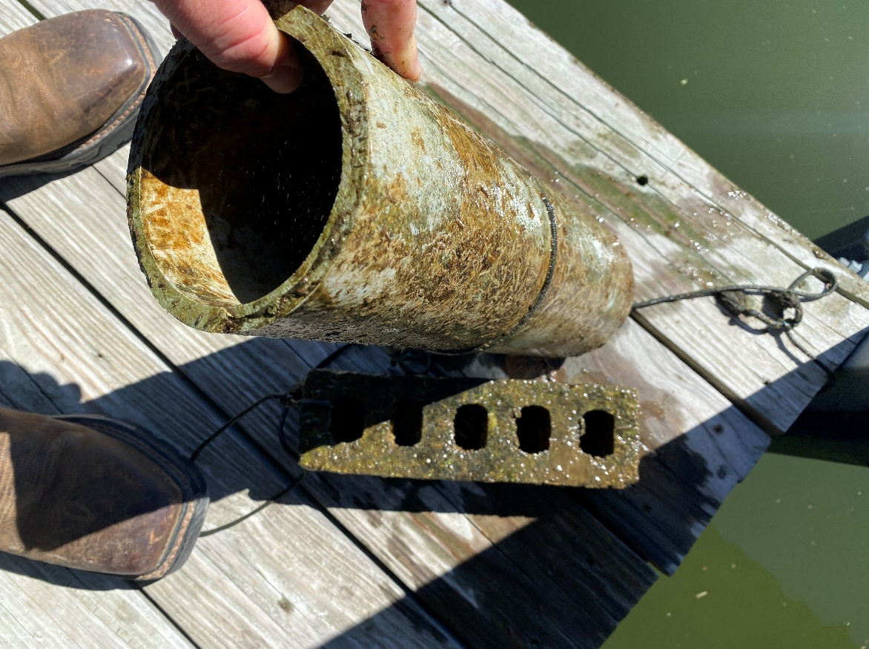

Fig 2: Palms Marina
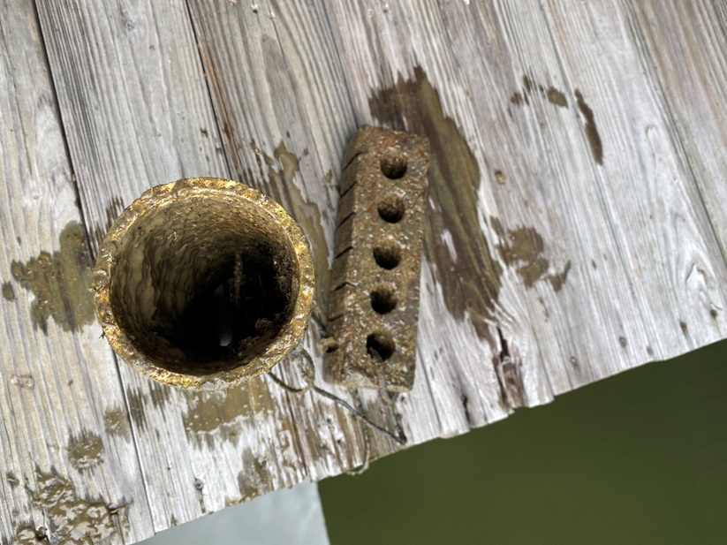

Fig 3: Palms Marina
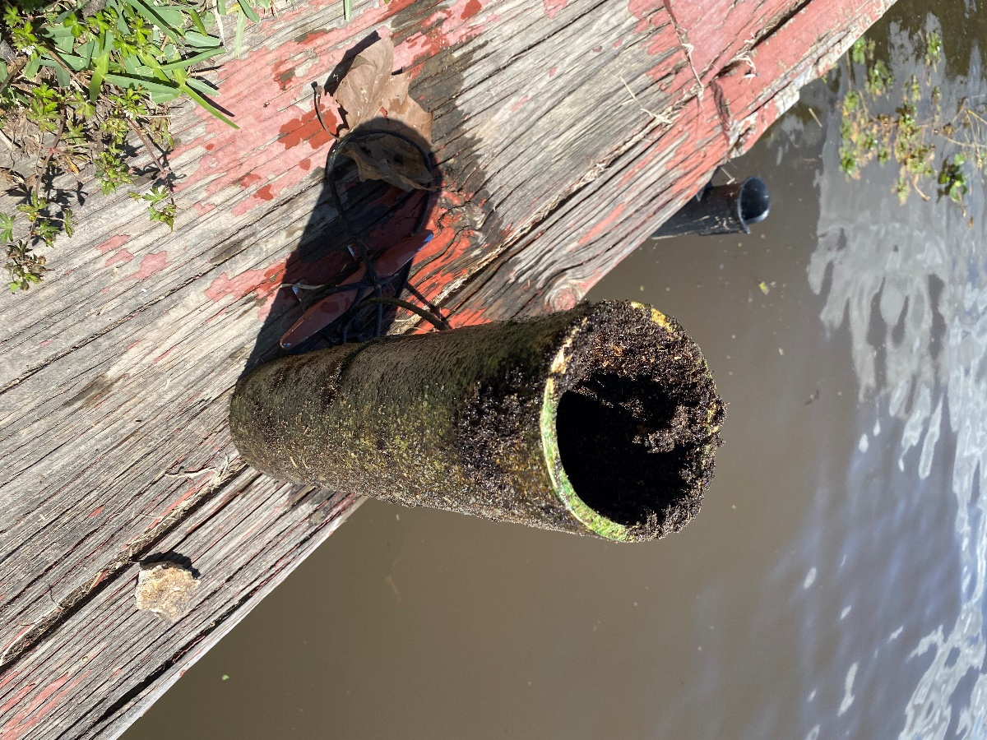

Fig 4: Sam Houston Estates boat ramp
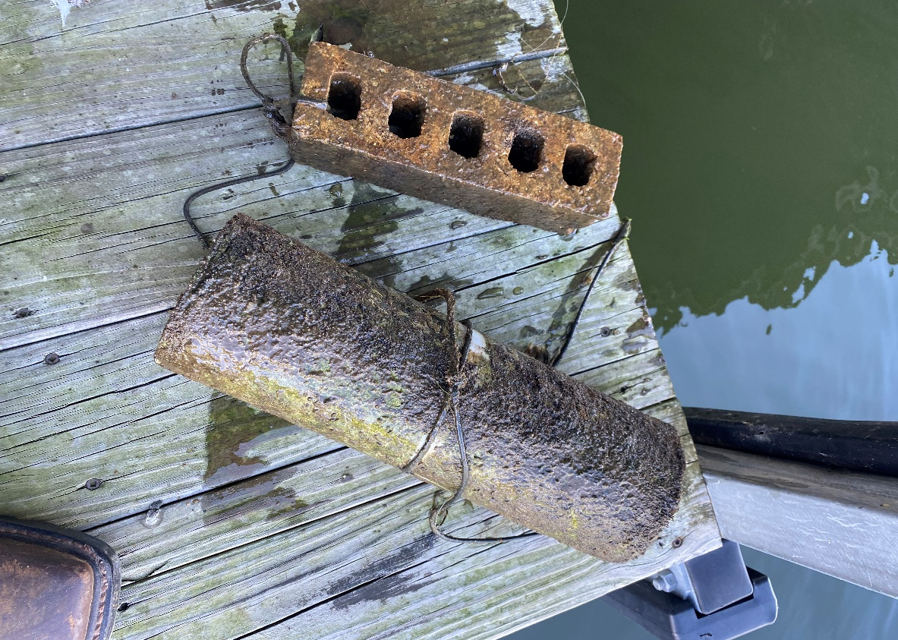

Fig 5: Palms Marina
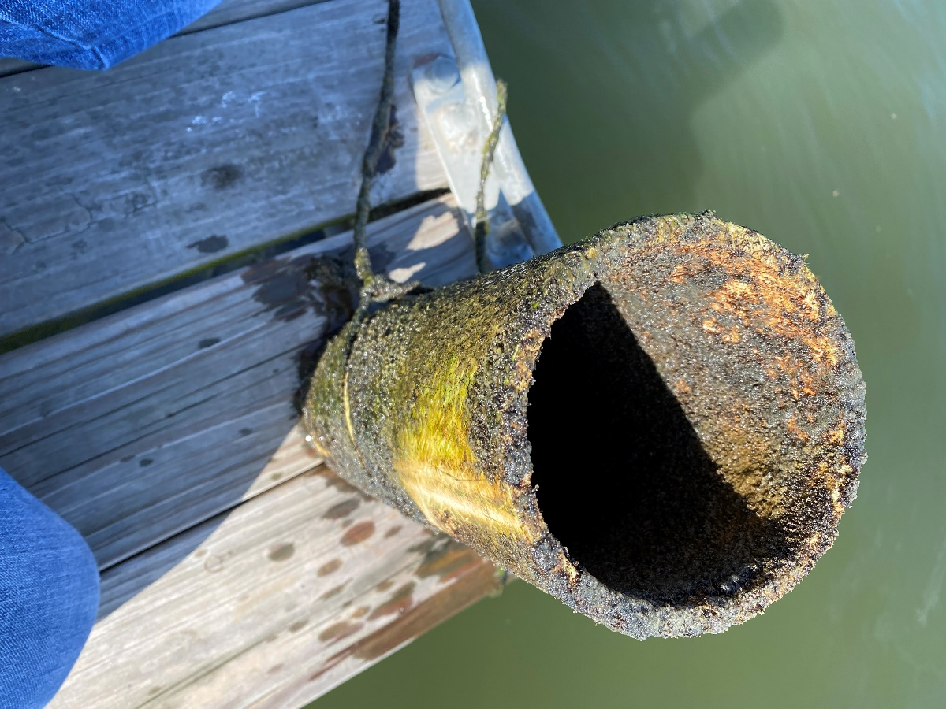

Fig 6: Pier 105 marina
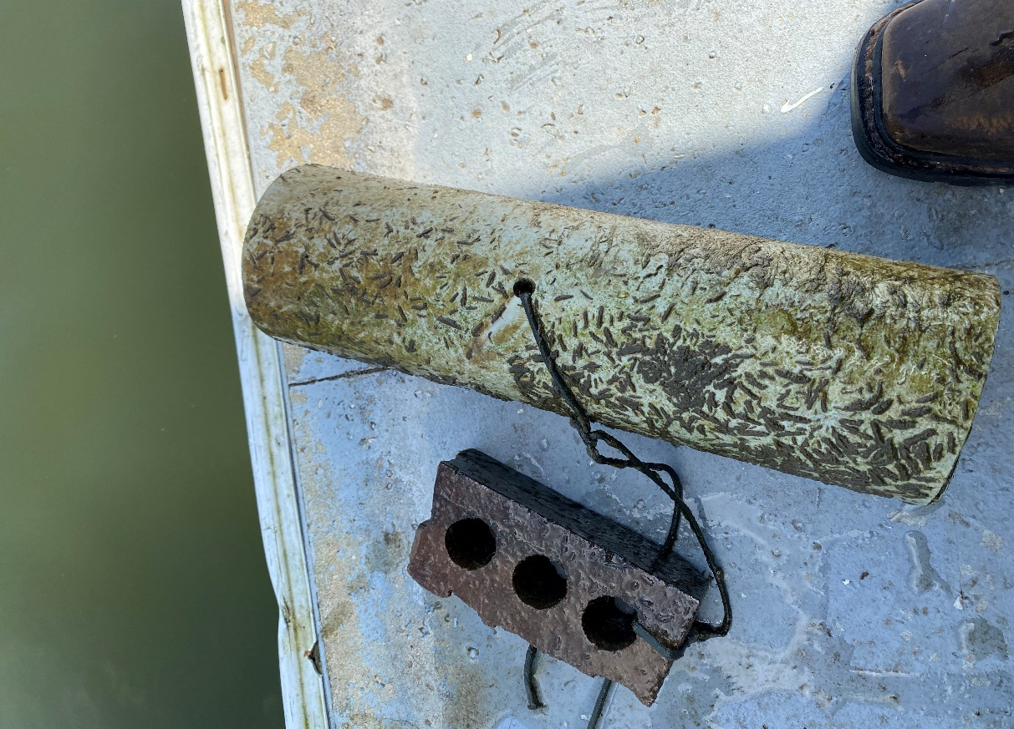

Fig 4: Walden Marina

